28th Annual Utah Tree Climbing Championship

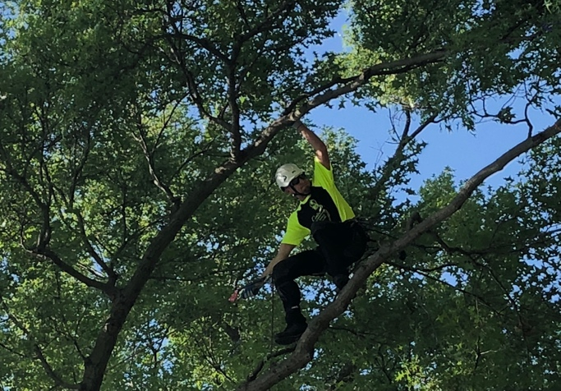  Photo courtesy of Val Bleazard |  |  | June 10 -12, 2021  Rain or shine!  Lester Park  663 – 24th Street  Odgen, UT 84401  3 CEUs for ISA Certified Arborists

Directions to Lester Park. Driving North on I-15: Continue on I-15 N to Ogden. Take exit 342 to UT-53 E. Drive on UT-53 to the park (it will be on your right side).

Thursday, June 10, 2021  Competitors are required to have their gear checked on Thursday evening anytime between 5-8pm at Lester Park. Competitors arriving for gear check without their gear check forms completed will not be allowed to climb. Complete your forms BEFORE coming.  Visit www.isa-arbor.com for complete rules, scoring, and regulations.  Note: Due to no ITCC, some events might be altered.  Registration is limited to 45 climbers. | Friday, June 11, 2021  Competitors are required to attend.  Arrive early, we will start promptly!  7:30 am – Registration  8:30 am – Welcome  9:00 am – Event walk through and rule review  10:30 – Competitors will compete in four of these events: Work Climb, Aerial Rescue, Speed Climb, Ascent Event, and Throw Line.  Lunch provided for climbers & judges, but no break.  Times are subject to change. |  |  | Saturday, June 12, 2021  Arrive early, we will start promptly!  7:30 am – Competitor Check-in  8:00 am – Competitors will compete in one of these events: Work Climb, Aerial Rescue, Speed Climb, Ascent Event, and Throw Line.  Lunch provided for climbers & judges, but no break.  10:00 am – Children’s Tree Climb  11:00 am – Preliminary Event  Awards  Times are  subject to  change.  11:30 am – Drawing*  12:30 pm – Master’s  Challenge  3:30 pm – Master Challenge Awards
Competitors must bring the following climbing equipment:
Boots and Hardhat with chin strap Throw Ball and Line Climbing Saddle and 150’ Rope
Double Locking Carabiners Flip Line or Lanyard Handsaw

PRIZES – Medals for placement winners.  Individual first place event winners each receive $100.  The Master’s Challenge winner receives $500 plus a chainsaw from Stihl and climbing gear from Arbor Master; second place is $500; third place is $300; and fourth place $200. |  | To be a sponsor, please call 801-446-8229  or email  Lisa@UtahUrbanForest.org |  |  | Food may or may not be available for spectators to purchase.  Vendors donate equipment to be used for drawings on Saturday including a chain saw, climbing hardware, and other equipment. Tickets will be sold at the event.  Climbers receive two T-shirts when fees are paid by May 3.

28th Annual Utah Tree Climbing Championship Registration Form
Both sides of this section must be completed by each competitor.
- To win and represent the ISA-Utah Chapter, I have been a member in good standing of the Utah ISA Chapter since February 28, 2021, and live and work within 300 miles of Salt Lake City, Utah.  - I will attend the equipment check on Thursday, June 10, 2021 at Lester Park. The equipment I bring to the equipment check will be used at the tree climbing event, is appropriate for tree climbing, and meets or exceeds minimum accepted industry safety standards.  - I understand that due to COVID, ISA will not be having an ITCC or NATCC for 2021.  - My registration fee must be paid by May 3, 2021 to receive T-shirts. If payment is received after May 3, T-shirts are not guaranteed.  T-shirt size: Small Medium  Large XLarge XXLarge  I have read and agree to these statements.  _______________________________________  Climber Name  ___________________________________  Date  Registration must be received by May 3, 2021 to receive a short sleeve and long sleeve T-shirt. If received after May 3, T-shirts are not guaranteed.  Registration is limited to 45 climbers. | Name_____________________________________________  Company _________________________________________  Address___________________________________________  _________________________________________________  _________________________________________________  _______________________________________________  Email  _______________________________________________  Phone  Registration Fees (please check one):  Registration must be received by May 3rd for t-shirt  Member of UCFC/ISA-UC:  Competitor $100 (Climb & CEU's)  Non-Members:  Competitor $145 (Climb & CEU's)  For CEUs only:  Non-Competitor $75 (For CEU's only, must attend)  Registration/Payment Options:  - Email form to lisa@utahurbanforest.org  - Online Registration at www.utahurbanforest.org  - Payment by credit card – Print below or call Lisa at 801-446-8229  - Mail registration and check payable to UCFC. Mail to Lisa Hanussak, 2506 W Cherry Grove Way, South Jordan, UT 84095  VISA MasterCard  Cardholder’s Name _________________________________  Card #____________________________________________  Exp Date _____/_____ Three #’s on back ____________  Person Authorizing _________________________________  Address and zip code of billing address for credit card:  ______________________________________________  ______________________________________________  ______________________________________________

