ISA UT Chapter/
Utah Community Forest Council
& Cherry Hills Farms

Fruit Tree Pruning Workshop

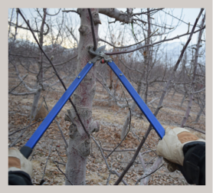

Monday,

March 7th, 2022

10 a.m. to 1:00 p.m.

645 South Alpine Highway
Alpine, Ut 84004
Follow signs after arriving at the Alpine fruit stand location

Learn the pruning principles for APPLE and PEACH trees such as:
light interception, fruit buds vs leaf buds, tree shaping, and more!

Cost: $50 per person
No lunchbreak

3 ISA CEU’s

Questions: Email lisa@utahurbanforest.org or Call (801) 446-8229

Fruit Tree Pruning Workshop

Monday, March 7, 2022

10 a.m. to 1:00 p.m.
(No lunchbreak)

CHERRY HILL FARMS
645 South Alpine Highway
Alpine, Ut 84004

3 ISA CEU’s

Registration Form

Name(s)

Company

Address

Phone (w/Area Code) Email Address

$50 person _____ # Attending _________ Total Cost
Email registration lisa@utahurbanforest.org
Online Registration at www.utahurbanforest.org
Telephone registration (801-446-8229)

Mail-in registrations to Lisa Hanussak, 2506 Cherry Grove Way, South Jordan, UT 84095.

Make checks payable to UCFC

Card #_______________________________________________ Expiration Date ________/________

Security Code ___________ Name on credit card ____________________________________________

Mailing address of your credit card_____________________________________________________________

Zip Code ________________________________

Person Authorizing __________________________________________________

Questions? Email lisa@utahurbanforest.org or Call (801) 446-8229

