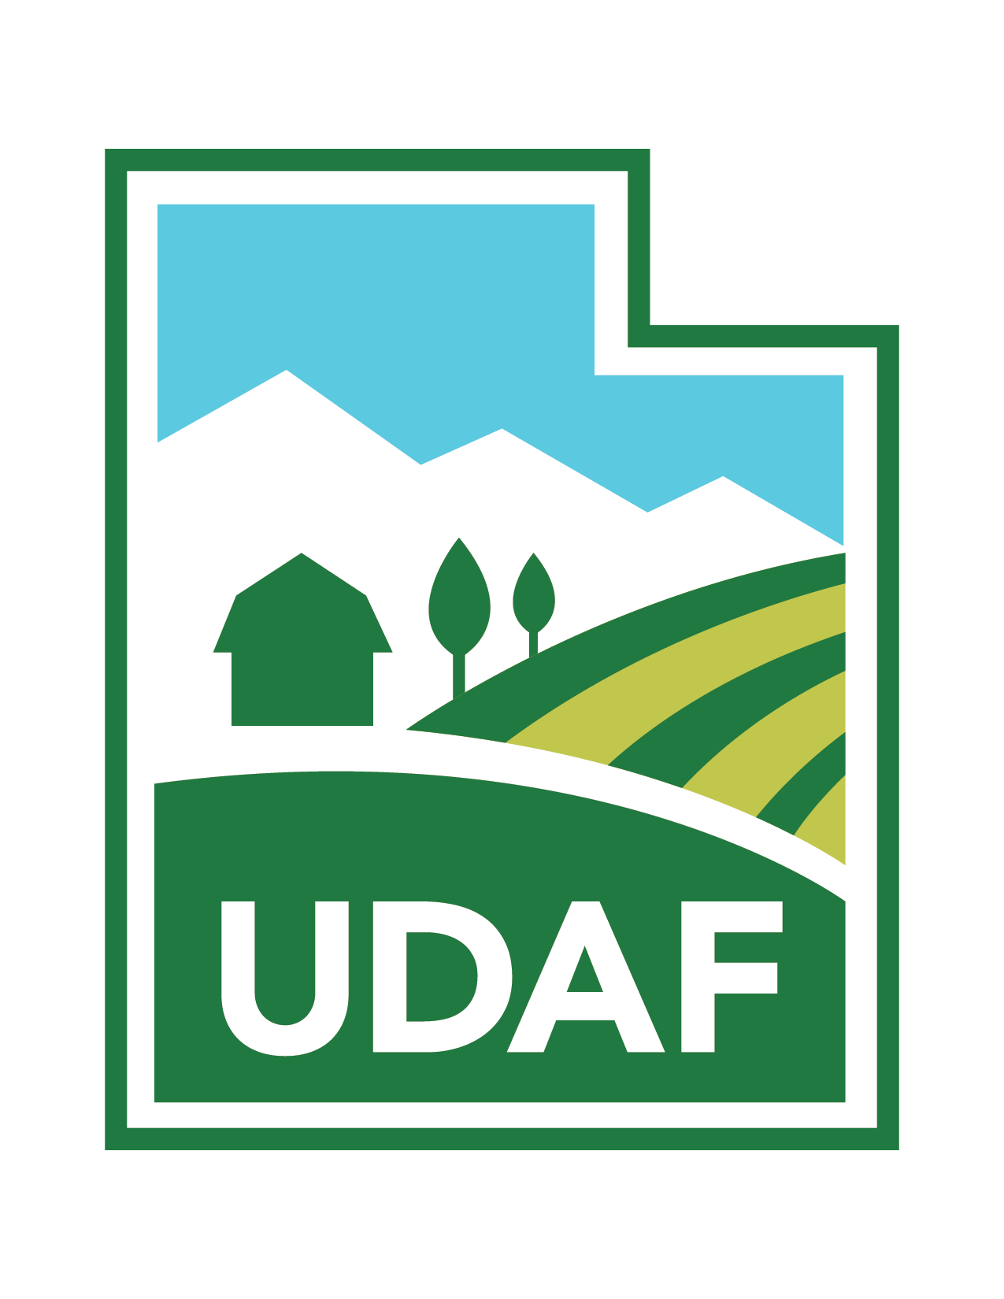
Utah Department of Agriculture and Food and
ISA UT Chapter/Utah Community Forest Council present:

Pesticide Workshop

Thursday, October 14, 2021

8:00 a.m. to 12:30 p.m.

USU Salt Lake Center
920 W Levoy Drive
Taylorsville, UT 84123

Topics: Pesticides, Fungicides, & Insecticides

Instructors:
- Jim Gish who has worked for BYU for 20 years and plant health care for 20+ years
- UDAF Representative - TBD

Cost: $75 includes lunch

Limited to 50 attendees only

2 Hours Pesticide Safety CEU’s
2 Hours Pesticide Law CEU’s

4 ISA CEU’s

Questions: Email lisa@utahurbanforest.org or Call (801) 446-8229

Pesticide Workshop

Thursday, October 14, 2021

8:00 a.m. to 12:30 p.m. (Lunch Provided)

USU Salt Lake Center
920 W Levoy Drive, Taylorsville, UT 84123

Registration Form

Name(s)

Company

Address

Phone (w/Area Code) Email Address

Dietary Restrictions if any

* Registration Fees include lunch. Pre-registration by Friday, October 8th is required to assure the availability of a lunch.

$75 per person _____ # Attending _________ Total Cost

Email registration lisa@utahurbanforest.org
On-line registration at www.utahurbanforest.org
Telephone registration (801-446-8229)

Mail-in registrations to Lisa Hanussak, 2506 Cherry Grove Way, South Jordan, UT 84095.

Make checks payable to UCFC

Card #_______________________________________________ Expiration Date ________/________

Security Code ___________ Name on credit card ____________________________________________

Mailing address of your credit card bill_________________________________________________________

Zip Code______________ Person Authorizing __________________________________________________

Questions? Email lisa@utahurbanforest.org or Call (801) 446-8229

