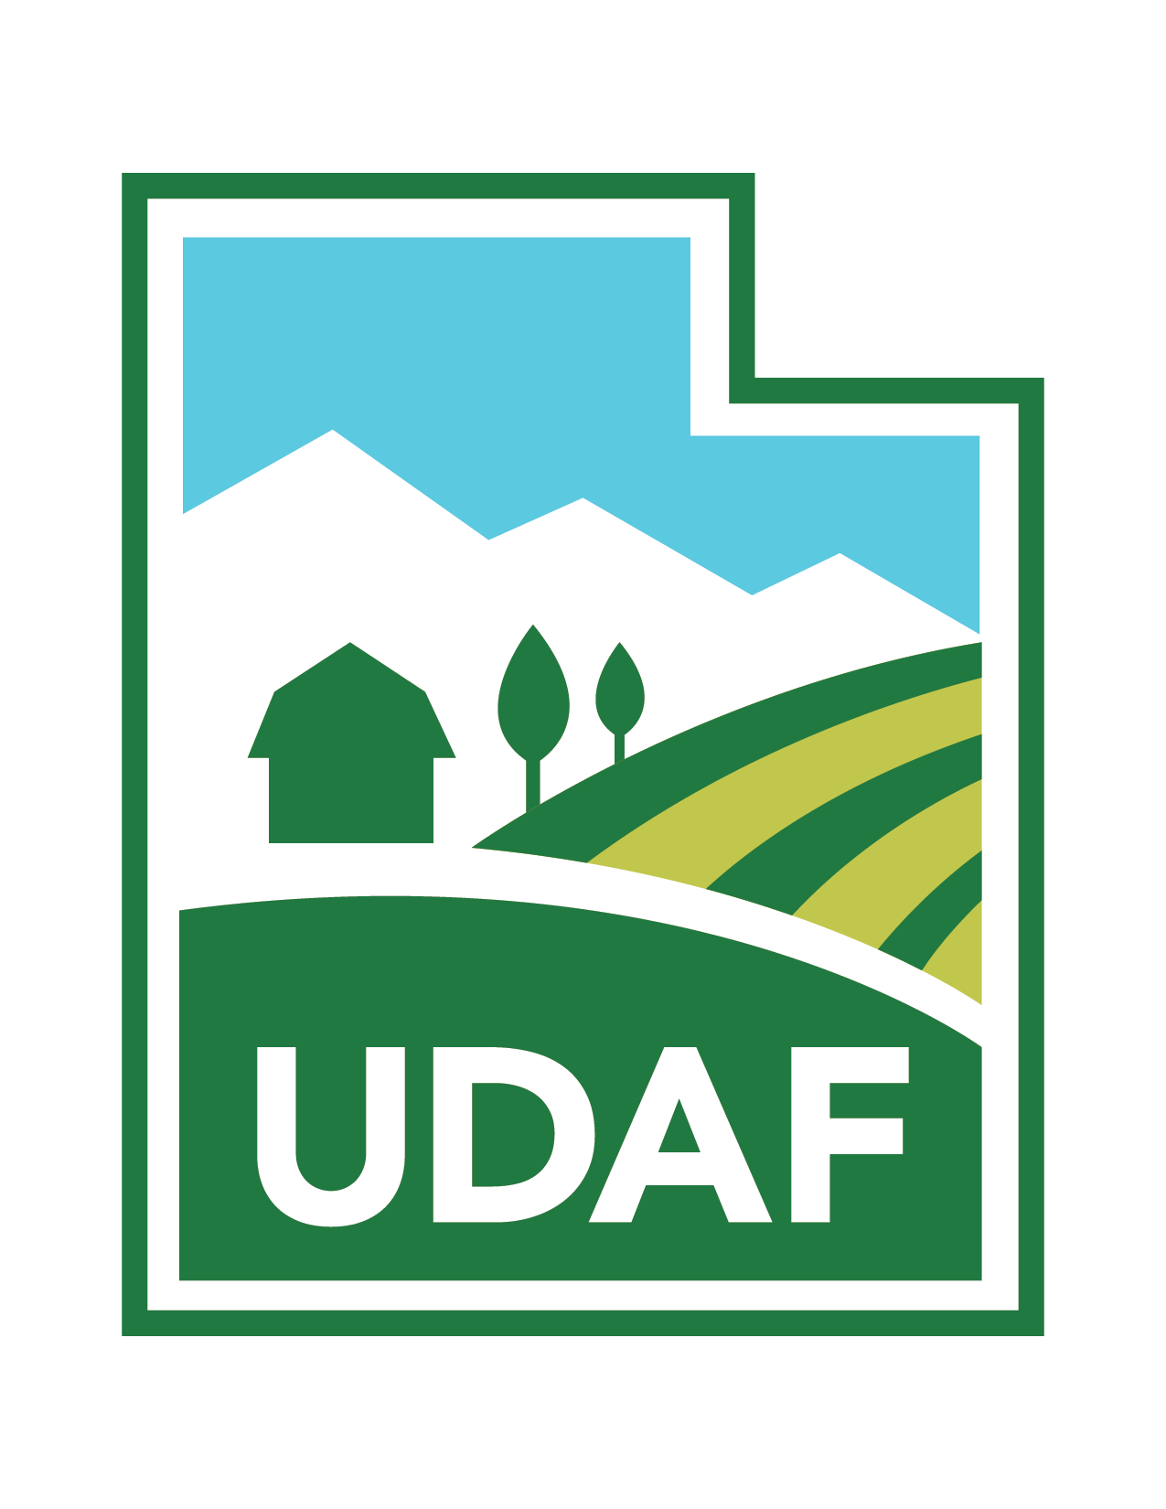
Utah Department of Agriculture and Food and
ISA UT Chapter/Utah Community Forest Council present:

Pesticide Workshop

Wednesday, October 11, 2023

8:00 a.m. to 12:30 p.m.

USU Salt Lake Center
920 W Levoy Drive
Taylorsville, UT 84123

Topics: Pesticides, Fungicides, & Insecticides

Instructors:
- Jim Gish who has worked for BYU for 15 years and plant health care for 40+ years
- UDAF Representative - TBD

Cost: $75 includes lunch for UCFC Members
$90 includes lunch for non-UCFC Members

Online Registration: Click here

Limited to 75 attendees only

2 Hours Pesticide Use CEU’s
2 Hours Pesticide Law CEU’s

4 ISA CEU’s

Questions: Email lisa@utahurbanforest.org or Call (801) 446-8229

